Sprint 10

# Cost Effectiveness to run Transfer Family

[Managed File Transfer—AWS Transfer Family Pricing – Amazon Web Services](https://aws.amazon.com/aws-transfer-family/pricing/)

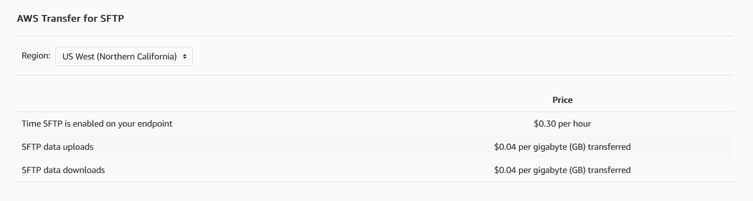

## How the cost is calculated for Transfer Family.

[AWS Pricing Calculator](https://calculator.aws/#/addService/TransferFamily)

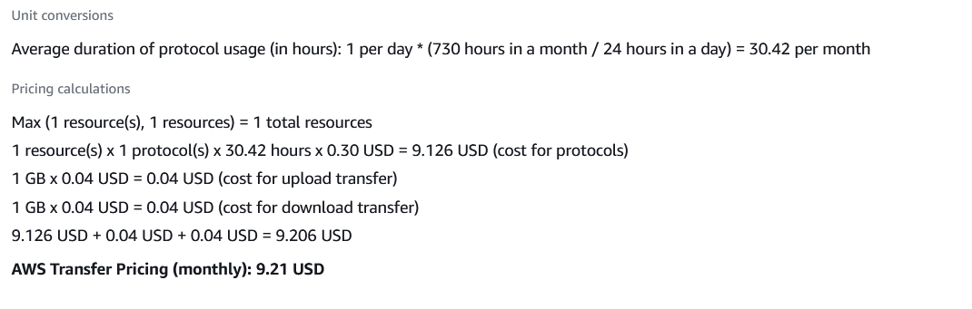

The conclusion is that it is more expensive to have more than one SFTP server so managing one SFTP server with multiple folders for schools or organizations is the less costly approach

# Tracking user upload and download metrics

CloudWatch is a monitoring service for AWS resources and applications. CloudTrail is a web service that records API activity in your AWS account.

## Using CloudWatch

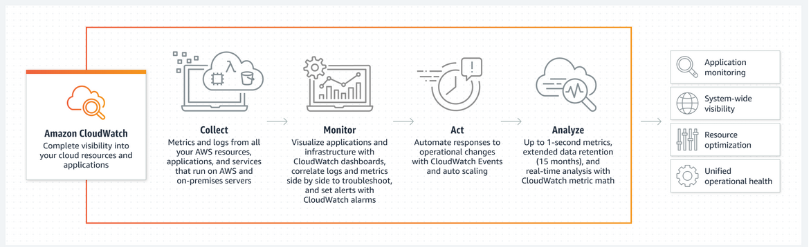

### Pricing

Metrics:

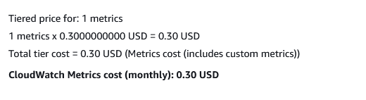

[AWS Pricing Calculator for CloudWatch](https://calculator.aws/#/addService/CloudWatch)

Metrics are uniquely defined by a namespace, and zero or more dimensions. Each data point in a metric has a time stamp and a unit of measure.

[Amazon CloudWatch concepts for Metrics](https://docs.aws.amazon.com/AmazonCloudWatch/latest/monitoring/cloudwatch_concepts.html#Metric)

### Metrics that are shown in the Transfer Family

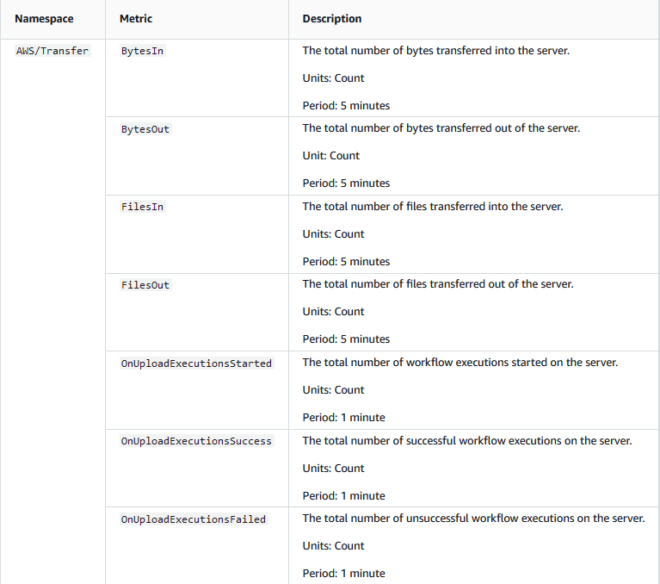

Seems like the metrics that are shown if you are looking at the monitoring system on the Transfer Family: [View server details - AWS Transfer Family](https://docs.aws.amazon.com/transfer/latest/userguide/configuring-servers-view-info.html). Only shows the total amount of files being uploaded and downloaded separately. Doesn’t show the metrics for uploads and downloads for individual folders. It might be done on the CloudWatch page using logs or we can monitor the S3 bucket.

[Monitoring server usage - AWS Transfer Family](https://docs.aws.amazon.com/transfer/latest/userguide/monitoring.html)

### CloudWatch: Log Activity

CloudWatch Logs can be used to monitor, store, and access log files from different sources such as Transfer family or S3 buckets.

To Create a Log Activity with CloudWatch: [Monitoring server usage - AWS Transfer Family Log Activity](https://docs.aws.amazon.com/transfer/latest/userguide/monitoring.html#monitoring-enabling)

1. Create an IAM policy
2. Create an IAM role and attach a policy

[Amazon CloudWatch Logs](https://docs.aws.amazon.com/AmazonCloudWatch/latest/logs/WhatIsCloudWatchLogs.html)

### CloudWatch S3 usage

Since we are using a one-transfer family server, if we are not able to get metrics for individual folders in the bucket, we monitor the metrics of the S3 bucket. Below is an AWS guide on S3 guide and a Video on how to use the S3 monitoring system.

[Monitoring metrics with Amazon CloudWatch - Amazon Simple Storage Service](https://docs.aws.amazon.com/AmazonS3/latest/userguide/cloudwatch-monitoring.html)

[Monitoring Resources on AWS: CloudWatch Metrics and Dashboards](https://youtu.be/9qKryBb7t6s?t=2406)

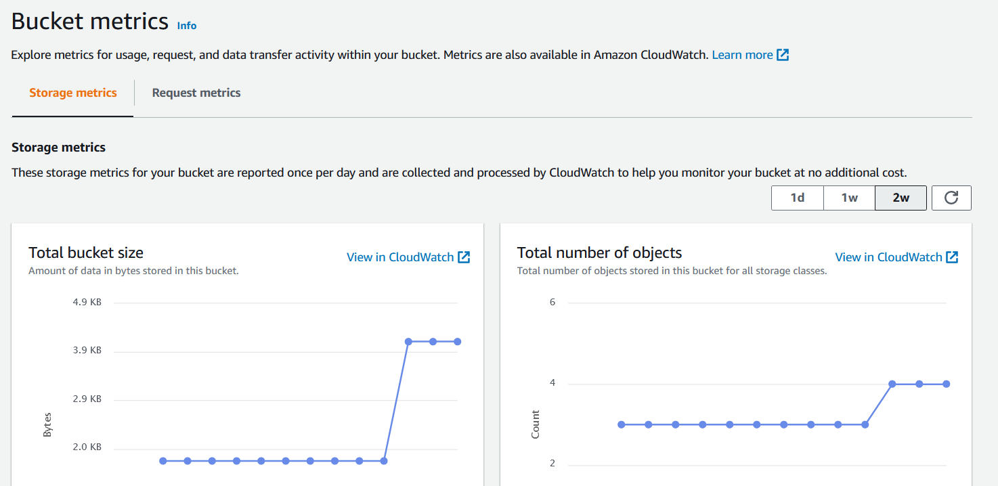

Create an S3 Alarm to both Bytes download and Upload for folders if possible

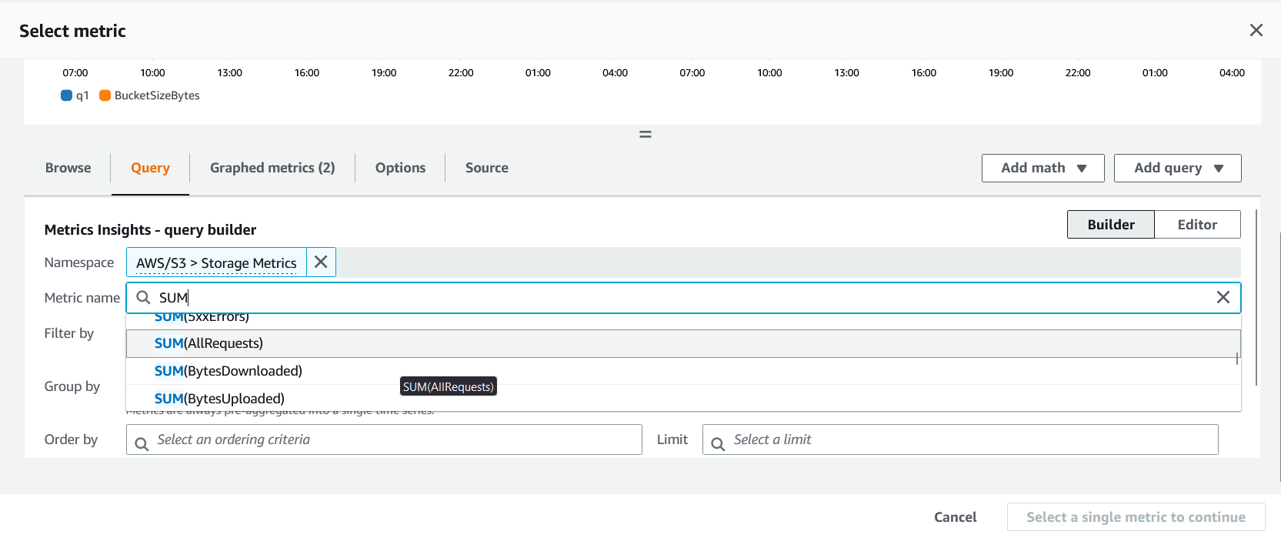

A transfer family can have many buckets: [AWS Transfer Family customers can now use Amazon S3 Access Point aliases for granular and simplified data access controls](https://aws.amazon.com/about-aws/whats-new/2021/10/aws-transfer-family-amazon-s3-access-point-aliases/)